# Multilevel Truncated Negative Binomial Model Results

## Fixed Effects Coefficients

| Estimate | Std. Error | z value | P-value | Variable |
| --- | --- | --- | --- | --- |
| -0.6362 | 0.5174 | -1.2296 | 0.2188 | (Intercept) |
| 0.0012 | 0.0033 | 0.3501 | 0.7263 | import_from_slu_log |
| 0.0070 | 0.0001 | 50.8607 | 0.0000 | age |
| 0.2461 | 0.0660 | 3.7269 | 0.0002 | distance_miles_log |
| -0.0390 | 0.0208 | -1.8797 | 0.0601 | state_unemployment |
| -0.0005 | 0.0018 | -0.3059 | 0.7596 | immigrant_density |
| 0.0089 | 0.0036 | 2.4973 | 0.0125 | sex_enc1 |
| 0.0193 | 0.0121 | 1.6002 | 0.1096 | marital_status_enc1 |
| 0.0278 | 0.0044 | 6.3744 | 0.0000 | marital_status_enc2 |
| 0.1210 | 0.0203 | 5.9617 | 0.0000 | employment_status_enc1 |
| -0.0493 | 0.0283 | -1.7433 | 0.0813 | employment_status_enc2 |
| 0.3983 | 0.0232 | 17.1546 | 0.0000 | purpose_simple2 |
| 0.1219 | 0.2722 | 0.4476 | 0.6544 | purpose_simple3 |
| 0.3745 | 0.0294 | 12.7508 | 0.0000 | purpose_simple4 |
| 0.2711 | 0.0227 | 11.9539 | 0.0000 | purpose_simple5 |
| 0.1561 | 0.0092 | 16.9690 | 0.0000 | accomd_type_enc1 |
| 0.3121 | 0.0051 | 61.1616 | 0.0000 | accomd_type_enc2 |
| 0.1085 | 0.0053 | 20.5987 | 0.0000 | season_enc1 |
| 0.0815 | 0.0053 | 15.5127 | 0.0000 | season_enc2 |
| 0.1608 | 0.0054 | 29.8303 | 0.0000 | season_enc3 |
| 0.4239 | 0.0201 | 21.0713 | 0.0000 | tourist_type_enc1 |
| 0.0337 | 0.0098 | 3.4194 | 0.0006 | tourist_type_enc2 |

## Incident Rate Ratios (IRR) for Fixed Effects

Incident Rate Ratios for Fixed Effects

| Variable | IRR | Lower CI | Upper CI | P-value |
| --- | --- | --- | --- | --- |
| (Intercept) | 0.5293 | 0.1920 | 1.4592 | 0.2188 |
| import_from_slu_log | 1.0012 | 0.9947 | 1.0077 | 0.7263 |
| age | 1.0070 | 1.0067 | 1.0073 | 0.0000 |
| distance_miles_log | 1.2790 | 1.1237 | 1.4557 | 0.0002 |
| state_unemployment | 0.9617 | 0.9234 | 1.0017 | 0.0601 |
| immigrant_density | 0.9995 | 0.9960 | 1.0030 | 0.7596 |
| sex_enc1 | 1.0089 | 1.0019 | 1.0160 | 0.0125 |
| marital_status_enc1 | 1.0195 | 0.9957 | 1.0439 | 0.1096 |
| marital_status_enc2 | 1.0282 | 1.0194 | 1.0370 | 0.0000 |
| employment_status_enc1 | 1.1286 | 1.0846 | 1.1744 | 0.0000 |
| employment_status_enc2 | 0.9519 | 0.9005 | 1.0062 | 0.0813 |
| purpose_simple2 | 1.4894 | 1.4231 | 1.5587 | 0.0000 |
| purpose_simple3 | 1.1296 | 0.6625 | 1.9260 | 0.6544 |
| purpose_simple4 | 1.4543 | 1.3729 | 1.5404 | 0.0000 |
| purpose_simple5 | 1.3114 | 1.2544 | 1.3710 | 0.0000 |
| accomd_type_enc1 | 1.1690 | 1.1481 | 1.1902 | 0.0000 |
| accomd_type_enc2 | 1.3664 | 1.3528 | 1.3801 | 0.0000 |
| season_enc1 | 1.1147 | 1.1032 | 1.1262 | 0.0000 |
| season_enc2 | 1.0849 | 1.0738 | 1.0962 | 0.0000 |
| season_enc3 | 1.1745 | 1.1621 | 1.1869 | 0.0000 |
| tourist_type_enc1 | 1.5279 | 1.4688 | 1.5893 | 0.0000 |
| tourist_type_enc2 | 1.0342 | 1.0145 | 1.0544 | 0.0006 |

## Random Effects Variance Components

No random effect variance estimated for us_state_enc.

## Variance Inflation Factor (VIF)

VIF Values (Note: VIF > 5 may indicate multicollinearity)

| Variable | VIF |
| --- | --- |
| Predictor 1 | 1.25 |
| Predictor 2 | 1.37 |
| Predictor 3 | 1.32 |
| Predictor 4 | 1.21 |
| Predictor 5 | 1.35 |
| Predictor 6 | 1.02 |
| Predictor 7 | 1.22 |
| Predictor 8 | 1.01 |
| Predictor 9 | 1.32 |
| Predictor 10 | 1.10 |
| Predictor 11 | 1.04 |
| Predictor 12 | 1.07 |

## Model Comparison (Truncated vs Non-truncated)

ANOVA Model Comparison Results

| Df | AIC | BIC | logLik | deviance | Chisq | Chi Df | Pr(>Chisq) |
| --- | --- | --- | --- | --- | --- | --- | --- |
| 24 | 741,515.7 | 741,751.7 | -370,733.8 | 741,467.7 |  |  |  |
| 24 | 747,133.5 | 747,369.6 | -373,542.7 | 747,085.5 | 0 | 0 | 1 |

## Model Fit Statistics

| Statistic | Value |
| --- | --- |
| AIC | 741,515.7 |
| BIC | 741,751.7 |
| Log-likelihood | -370,733.8 |

## Predicted vs Observed Length of Stay

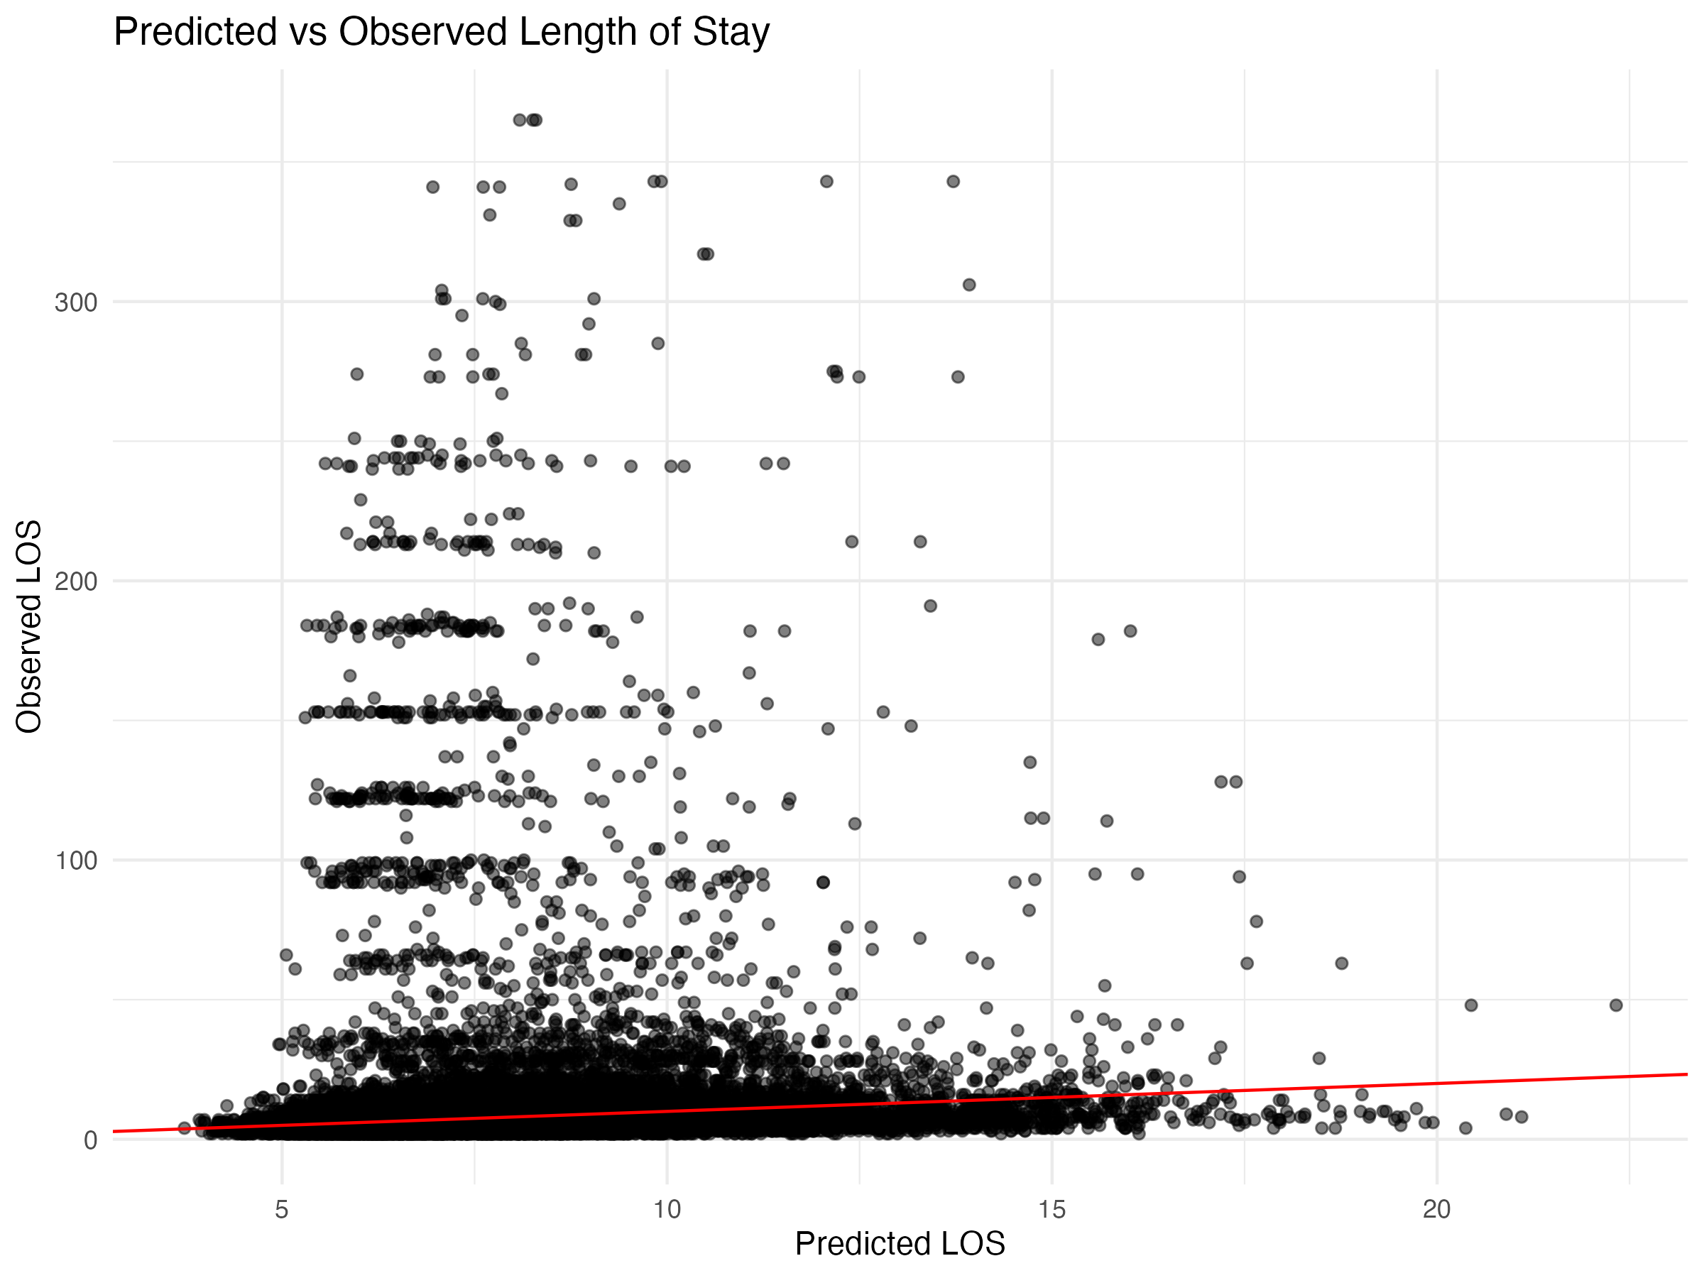

## Diagnostic Plots

### DHARMa Residuals

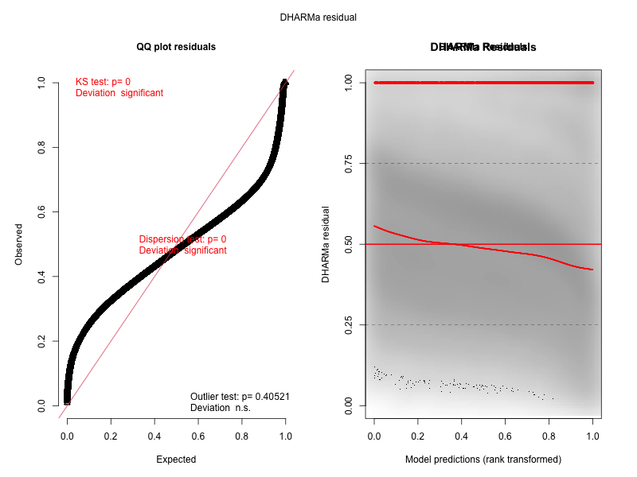

### Residuals by State

